Effect of The Use of Reduced Graphene Modified “Black {001} TiO2” Nanosheets on Ethylene Removal and Quality Attributes of Tomatoes during storage
Syed Mudabbar Hussain Shah (syedmudabbarhussain.shah@unina.it)
Dept. Agricultural Sciences, University of Naples Federico II, Portici (NA), Italy
Tutors: Prof. Silvana Cavella, Prof. Elena Torrieri

The objective of my PhD project is to develop a decision support system (DSS) that can simulate and forecast the shelf-life of fruits and vegetables from distribution to consumption. One of the specific objectives of the work was to study the impact of environmental storage factors on quality indices changes of product. In this context, the aim of this work was to evaluate the performance of a novel synthesized nanocomposite based on reduced graphene oxide (rGO) modified anatase {001} black TiO2 nanosheets (rGO-BTiO2 NSTs) on ethylene removal efficiency and its effect on quality attributes of stored tomatoes.

Effetto dell'uso di nanoparticelle "Black {001} TiO2" modificati con grafene ridotto sulla rimozione dell'etilene e attributi di qualità dei pomodori durante la conservazione
L'obiettivo del progetto di dottorato è quello di sviluppare un sistema di supporto alle decisioni (DSS) in grado di simulare e predire la shelf life di prodotti ortofrutticoli dalla distribuzione al consumo. Uno degli obiettivi specifici del progetto è studiare l’impatto delle condizioni di conservazione sulla qualità del prodotto. In questo contesto, lo scopo di questo lavoro è stato valutare le prestazioni di un nuovo nanocomposito sintetizzato basato su nanoparticele di TiO2 nero anatasio {001} modificato con ossido di grafene ridotto (rGO) (rGO-BTiO2 NST) sull'efficienza di rimozione dell'etilene e il suo effetto sugli attributi di qualità di pomodori conservati.

Keywords: Adsorption, black TiO2 NSTs, ethylene scavenging, photocatalysis, photolysis, postharvest quality, reduced graphene oxide, tomatoes.

1. Introduction
Fresh fruits and vegetables are highly perishable and require proper postharvest handling and storage to maintain their quality and extend their shelf life (Mditshwa et al., 2023). The ripening process of fruits is associated with the production of ethylene, which acts as a signaling molecule to promote ripening and senescence, it stimulates chlorophyll loss, enhances excessive softening, promotes discoloration and browning. Tomatoes are a highly perishable fruit with a relatively short shelf life of 1-2 weeks, depending on factors such as ripeness at the time of purchase, storage temperature, and humidity (Meiramkulova et al., 2023). In this study, we investigated the effect of reduced graphene modified "black {001} TiO2" nanosheets under UV light on ethylene removal and quality attributes of stored tomatoes. The main objectives of the study were: (A1) To evaluate the performance of the new photocatalytic material in removing ethylene and delaying the ripening of tomatoes during storage; (A2) The effect of the photocatalytic treatment on the quality attributes of the tomatoes, such as weight, titratable acidity, soluble solids, moisture content, and lycopene content.

2. Materials and Methods
The tomato plants were cultivated organically in a commercial field plot in Oro Verde (Chillán, Chile). Fruits were harvested at the breaker stage on two different dates (1 and 16 March 2023), and immediately transported to the laboratory and sorted for uniformity according to size and color. 36 fruits were randomly picked from a lot of 70 fruits measured in the values. In addition, 6 randomly chosen fruits were used to find and compare the properties of the raw materials. Tomatoes were stored in hermetically sealed glass desiccators at 12°C in darkness at a relative humidity of 88%. The fruit were stored at 12 °C and 88% relative humidity for 6 days (group 1) and 16 days (group 2) in hermetically sealed 10 L glass desiccators located within a climate incubator (BJPX-A500 II—Biobase Industry, Shandong Co. Ltd., Shandong, China). Four treatments were applied, including a control group, photolysis, adsorption, and photocatalysis. During storage of the tomato fruit, the concentrations of ethylene and carbon dioxide were measured after every two hours. Quality fruit parameters (weight, titratable acidity, soluble solids, moisture content, and lycopene content) were analyzed at the beginning of the experiments, and after 6 days and 16 days of tomato storage.

3. Results and Discussion
3.1 Evolution of Ethylene and carbon dioxide
The effect of different treatments on the evolution of ethylene and carbon dioxide over time can be observed in Figures 1 and 2. The removal of ethylene is minimum in photocatalysis; this can be due that the reduced graphene modified black TiO2 nanosheets having a large surface area, which provides more active sites for ethylene adsorption. The increased surface area also enhances the diffusion of ethylene molecules, which increases the chances of interaction with the active sites on the nanosheets. The photocatalytic activity could involve the generation of reactive oxygen species (ROS) upon light exposure. These ROS species, such as hydroxyl radicals (OH·), are highly reactive and can oxidize ethylene, leading to its decomposition.
Tomatoes undergo photosynthesis in which they utilize light energy to convert carbon dioxide (CO₂) and water into glucose and oxygen. During respiration, they consume oxygen and release CO₂. Black TiO2 is a modified form of titanium dioxide that enhances light absorption capabilities, which makes it an efficient photocatalyst for CO₂ reduction. The use of reduced graphene as a modifier enhances the electron transfer properties of TiO2, leading to a higher efficiency in photocatalytic CO₂ reduction.

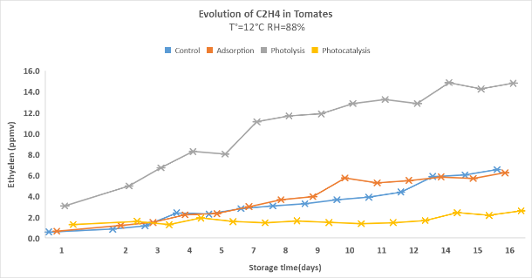 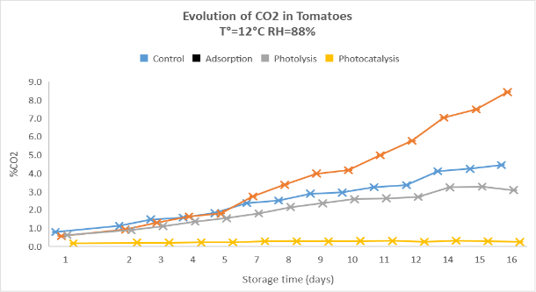
Figure1. C2H4 evolution during ripening of tomatoes Figure 2. CO2 evolution during ripening of tomatoes

3.2 Effect of treatments on tomato quality
Excessive loss of moisture in fresh fruits and vegetables is associated with a negative impact on quality, as a result they can lose their freshness. During our experiment we observed no significant effect of treatments on the weight loss of postharvest tomatoes after 6 days. However, after 16 days, a significant difference was observed (Table 1). The photocatalysis treatment may have slowed down the ripening process and reduced the rate of mass loss compared to the other groups (Li et al; 2022). The application of photocatalysis resulted in a decrease in the total soluble solids (TSS) content of tomatoes after 16 days, while no significant impact was observed after 6 days (Table 1). Maturity Index is a measure used in agriculture to assess the ripeness and quality of fruits and vegetables based on their physical and chemical characteristics (Prasad et al; 2018). In the case of tomatoes, the maturity index is often based on the levels of soluble solids (such as sugars) and acidity (such as citric and malic acid) present in the fruit. This was the most suitable quality parameter for assessing the postharvest performance of tomatoes, due to its increase and significant difference for t = 6 d and t = 16 d (Table 1). The different treatments applied in the experiment had an impact on the lycopene content of the tomatoes, particularly over the 16-day period. The photocatalysis treatment appeared to have a positive effect on the lycopene content of the tomatoes, particularly in the 16-day period. The accumulation of lycopene occurs due to the conversion of chloroplasts into chromoplasts, coupled to the synthesis of this red pigment. The lycopene content of tomatoes correlated positively to both surface and puree colours. This suggests that lycopene content depends upon tomato ripeness.
Table 1. Physicochemical and ripening indices of tomatoes
Groups | WL (%) | TSS (%) | MI (%) | Lycopene (mg kg⁻¹)
 | 6d 16d | 6d 16d | 6d 16d | 6d 16d
Raw Material | - - | 5.6±0.46 4.9±0.63 | 11.5±1.53 9.4±1.63 | 4.94±4.94 0.20±0.33
Control | 1.5±0.32 5.5±1.41 | 5.5±0.46 5.1±0.60 | 12.6±2.60 13.6±3.85 | 22.69±12.92 9.47±19.65
Catalysis | 1.9±0.49 5.8±3.21 | 5.8±0.52 4.9±0.49 | 12.8±1.73 11.7±3.38 | 23.23±13.04 12.82±10.72
Adsorption | 1.8±0.66 5.8±3.05 | 5.8±5.84 4.7±0.83 | 12.7±2.16 12.0±3.66 | 22.16±8.97 10.93±14.03
Photocatalysis | 1.6±0.34 4.5±1.12 | 5.6±0.43 4.7±0.60 | 12.5±1.37 9.8±2.83 | 24.95±21.60 22.55±11.46

4. References
Li W, Liu Z, Li X, Li X. (2022). Quality maintenance of 1-Methylcyclopropene combined with titanium dioxide photocatalytic reaction on postharvest cherry tomatoes. J. Food Process. Preserv.46: e16500.
Meiramkulova K, DevrishovD, Adylbek Z, Kydyrbekova A, Zhangazin S, Ualiyeva R, Temirbekova A, Adilbektegi G, Mkilima, T (2023). The Impact of Various LED Light Spectra on Tomato Preservation. Sustainability, 15(2): 1111.
Mditshwa A, Khaliq G, Hussein Z, Ejaz S (2023). Sustainable postharvest management practices for fresh produce. Front. sustain. food syst.7: 63.
Prasad K, Jacob S, Siddiqui M W (2018). Fruit maturity, harvesting, and quality standards. Preharvest Modulation of Postharvest Fruit and Vegetable Quality. Academic Press.

