Structuring Oil for Healthy and Sustainable Diets:
the Case Study of the Dried Template Approach

Francesco Ciuffarin (ciuffarin.francesco@spes.uniud.it)
Department of Agricultural, Food, Environmental and Animal Sciences, University of Udine, Via Sondrio 2/A, 33100 Udine, Italy
Tutor: Prof. Sonia Calligaris

The aim of this Ph.D. thesis is to develop innovative and environmentally-friendly methods for structuring liquid oils into soli-like materials, called oleogels. These materials are intended to be used as an alternative to saturated fats and/or as a functional ingredient for delivering health functionalities. To this aim, the feasibility of different structuring strategies has been explored. Hereafter, the strategy based on the exploitation of porous dried templates made of cellulose as an oil structurant was investigated.

Strutturazione di olio per diete sane e sostenibili: il caso studio del “dried template approach”
Lo scopo di questa tesi di dottorato è quello di sviluppare metodi innovativi ed ecocompatibili per strutturare oli liquidi in sostanze pseudoplastiche, note come oleogel. Questi materiali sono destinati ad essere utilizzati come alternativa ai grassi saturi e/o come ingredienti con proprietà salutistiche. A tal fine, diverse sono state le strategie studiate in questa tesi di dottorato. Qui di seguito verranno descritti i risultati relativi all’utilizzo di materiali disidratati porosi a base di cellulosa come agenti per la strutturazione dell’olio.

Keywords: oleogel, cellulose, cryogel, aerogel, particles

1. Introduction

Oleogelation can be defined as a process able to turn liquid oils into solid-like materials by exploiting the structuring properties of selected molecules, called oleogelators. Oleogels have been initially studied and developed as a feasible alternative to fats rich in saturated or trans fatty acids (e.g., animal fats, tropical oils, margarine, and shortenings) due to their good capability to mimic fat technological functionalities (Patel et al., 2020). However, the interest is today further increasing due to their possible health functionalities (Calligaris et al., 2020). Currently, two main approaches for oil structuring have been proposed in the literature. Direct methods involve the use of liposoluble molecules capable of forming three-dimension networks entrapping oil upon heating and further cooling. Several components, such as saturated monoglycerides, waxes, phytosterols, ethylcellulose, and chitin, have demonstrated good oleogelation capability. This technique is considered the simplest way to structure liquid oils, despite the drawbacks related to the heating process applied, potentially affecting oil stability, as well as some limitations associated with the current EU Regulation on food additives (Patel et al., 2014). On the other side, indirect methods rely on the exploitation of a structuring network made of hydrophilic molecules. This approach enables the use of widely consumer-accepted polymeric molecules, such as polysaccharides and proteins (Patel, 2020). Among the possible approaches categorized under the indirect methods, the dry template approach is one of the most promising. It consists of the formation of a hydrogel, which is further dried. The resulting scaffold is converted into an oleogel by allowing oil absorption (De Vries et al., 2015). The structure and the functionalities of this scaffold strictly depend on the drying technique applied (Manzocco et al., 2021). In general terms, it is expected that air-drying induces a strong network collapse leading to a material with low porosity (xerogel), whereas freeze-drying (cryogel) and supercritical-CO₂-drying (aerogel) are techniques able to reduce collapse generating highly porous structures able to absorb oils (Buchtová & Budtova, 2016).

In this PhD thesis, both direct and indirect methodologies to form oleogels have been investigated to quantitatively understand the structure-function relationships. Monoglycerides, waxes, and phytosterols were used to structure extra virgin olive oil (Ciuffarin et al., 2023), and the capability of the resulting oleogels to modulate lipolysis and polyphenol bioaccessibility was studied (Ciuffarin et al., submitted). Additionally, indirect methods have been applied by considering whey proteins and cellulose as potential oleogelators. In this paper, the feasibility of using a cellulose-based porous template for oleogel preparation will be described. Cellulose is a particularly attractive biopolymer being the most abundant polysaccharide on the Earth, not expensive and obtainable from agro-industrial vegetable side streams, in a closed loop that avoids the generation of large quantities of waste (Pires et al., 2022). In particular, monoliths of cryogels and aerogels were prepared by freeze-drying (FD) or supercritical-CO₂-drying (SCD) of cellulose hydrogels and characterized for their structural features (SEM microstructure, BET-specific surface area, porosity, pore volume, firmness, density and interaction with oil). In the last part of the work, to modulate oleogel functionalities, cryogel particles were considered instead of monoliths. The obtained results open interesting novel possibilities in using renewable cellulose materials for oil structuring.

2. Materials and Methods
2.1 Preparation of cellulose hydrogels, cryogel, and aerogel monoliths and particles
Cellulose hydrogels were prepared as described by Ciuffarin et al. (2023) starting from microcrystalline cellulose (Avicel®, pH-101, Sigma Aldrich). Briefly, cellulose was dispersed at -5 °C in an 8% NaOH-water solution to obtain a final concentration of 3, 4, and 5 % (w/w). Around 6 mL of the solution was poured into cylindrical polypropylene vials (2.7 cm in diameter) and heated at 50 °C for 2 h to allow gelling. The samples were finally washed until a pH of 7.0 was reached. The cellulose hydrogels were freeze-dried (Cryotec Cosmos, Saint-Gély-du-Fesc, France) to obtain cryogels; or dried with supercritical CO₂ (Homemade set-up of PERSEE Mines Paris, France) after a phase of solvent substitution (water with ethanol) to obtain aerogels (Ciuffarin et al., 2023).
For cryogel particle preparation, 5% (w/w) cellulose hydrogel monoliths were ground in a ratio of 2:1 with deionized water using a high-speed homogenizer (DI 25 Basic, IKA Werke, Staufen im Breisgau, Germany) at 14,000 rpm for 3 min. The obtained viscous solution was placed in aluminum containers and freeze-dried (72 h, -80 °C, 10 mTorr). Since cryogel particles presented uneven size (56.4% < 100 µm, 39.8% in the range of 100-500 µm, and 1.3% > 500 µm), they were sieved, and only particles with dimensions lower than 100 µm were collected and used to prepare oleogels. Dried monoliths and particles were stored in desiccators containing granular silica gel at room temperature until analysis.

2.2 Oleogel preparation
After preliminary trials, here not described, the best preparation conditions needed to obtain a self-standing material with no visible oil release were defined by mixing sunflower oil and cryogel particles. In particular, cellulose cryogel particles were manually mixed with sunflower oil at a 1:2.4 ratio (w/w).

2.3 Structural characterization of cryogel and aerogel monoliths and particles
Macroscopic images. Sample images were acquired using an image acquisition cabinet and a Google Pixel 6 (Alphabet, Mountain View, California, USA). The light was provided by a LED strip properly placed to minimize shadow and glare.
Microstructure. SEM micrographs were obtained using a MAIA-3 (Tescan, Brno, Czech Republic), equipped with detectors of secondary and back-scattered electrons. The internal cross-section of the samples was coated with a 14 nm layer of platinum with a Quorum Q150T metallizer (Quorum Technologies, East Sussex, UK) to prevent the accumulation of electrostatic charges and image defaults. The observations were performed with an acceleration voltage of 3 kV.
Volume. Monolith volume was measured by a CD-15APXR digital caliper. Volume variation (ΔV, %) during the conversion of hydrogels to cryogels or aerogels was measured.
Density, porosity, pore volume. Monolith envelope density (ρ_{envelope}) was measured using the Micromeritics GeoPyc 1360 Envelope Density Analyzer (Norcross, Georgia, USA) with the DryFlo® powder as a fluid medium. Each sample was measured in 5 cycles with an applied force of 27 N. Porosity (eq. 1) and pore volume (eq. 2) were calculated from the envelope (ρ_{envelope}) and cellulose skeletal density (ρ_{skeletal} = 1.5 g cm⁻³, (Sun, 2005)):
$Porosity \left(\%\right)=\left(1-\frac{ρ_{envelope}}{ρ_{skeletal}}\right)∙100$ (eq. 1)
$Pore volume ({cm}^{3}g^{-1})= \frac{1}{ρ_{envelope}}-\frac{1}{ρ_{skeletal}}$ (eq. 2)
Specific surface area. Monolith-specific surface area (S_{BET}) was determined by measuring N₂-adsorption isotherm at 77 K with the Micromeritics ASAP 2020 (Norcross, Georgia, USA) and using Brunauer, Emmett, and Teller (BET) approach (Brunauer et al., 1938). Prior to measurements, samples were degassed for 5 h at 70 °C.
Cryogel particle density. The density (g cm⁻³) of cryogel particles and microcrystalline cellulose (control) was measured by weighing 1 mL of dried material in a graded cylinder.
Cryogel particle size. Particle size was measured by using a vibrating sieve equipped with 2 different sieves (100, and 500 µm). The separated fraction was weighted and the distribution, over the total weight, was evaluated.

2.4 Monoliths interaction with oil
Monoliths oil absorption kinetics. Monoliths were cut into 1 cm³ cubes volume, weighted (W₀), and immersed into Petri plates containing sunflower oil at room temperature. At defined time intervals, samples were withdrawn, wiped with absorbent paper, and weighed (W_{t}). The experiment was carried out until a constant weight was reached (plateau or equilibrium value), as indicated by no weight variation in 3 consecutive measures. Absorbed oil at each time was expressed as the ratio between weight gain at time t (min) and the initial weight of the cryogel or aerogel sample (eq. 3).
$Absorbed oil \left(g_{oil}/g_{dry matter}\right)= \frac{\left(W_{t}-W_{0}\right)}{W_{0}}$ (eq. 3)
The maximum oil absorption capacity was taken at equilibrium.
Oil holding capacity. At monoliths absorption equilibrium, around 100-200 mg of sample (W₁) was placed into 1.5 mL microtubes and centrifuged at 15,000 ×g for 30 min (Mikro 120, Hettich Zentrifugen, Andreas Hettich GmbH and Co, Tuttlingen, Germany). After centrifugation, the released oil was accurately wiped using absorbing paper and the sample was weighted again (W₂). Oil holding capacity (OHC) was calculated as the percentage ratio between the weight of oil retained in the sample after centrifugation and the total oil weight initially present (eq. 4).
$Oil Holding Capacity \left(\%\right)=\frac{{S ∙ W_{1}-(W}_{1} - W_{2})}{S ∙ W_{1}}∙100$ (eq. 4)
where S represents the weight fraction (%) of the oil initially present in the sample. The same centrifugation procedure was performed for the oleogel sample.

2.5 Oleogel characterization
Confocal microscopy. A 0.2 % Nile Red aqueous solution and 0.01% of Fluorescent Brightener 28 were used to stain the oil and the cellulose, respectively, by gently hand-mixing the oleogel samples. Cryogel particles were placed on the microscope slide, covered with a cover slip, and observed at 100× magnification (Leica TCS SP8 X confocal system, Leica Microsystems, Wetzlar, Germany). Images were elaborated using the software LasX 3.5.5.
Firmness. Firmness was evaluated using an Instron 4301 (Instron LTD., High Wycombe, UK) with a 6.2 mm diameter cylindrical probe and a 1 kN compression head. Monoliths and oleogel samples were compressed at a crosshead speed of 25 mm min⁻¹, and the maximum force (N) needed to penetrate the sample by 2 mm was measured.
Rheological properties. Oleogel viscoelastic properties were tested using an RS6000 Rheometer (Thermo Scientific RheoStress, Haake, Germany), equipped with a Peltier system. Measures were performed using a parallel plate geometry at 20 °C with a gap of 2.0 mm. Oscillatory sweep tests to identify the linear viscoelastic region (LVR) were performed increasing stress from 1.0 to 1.0 × 10⁴ Pa at 1 Hz frequency. Critical stress (Pa) was identified as the stress value corresponding to a 10% drop in G′ value. Frequency sweep tests were then performed increasing frequency from 0.1 to 10 Hz at stress values selected in the LVR and G' – G'' recorded at 1 Hz.

2.6 Statistical analysis
Data were obtained by at least triplicate measurements. Data were reported as mean ± standard deviation and subjected to one-way analysis of variance (ANOVA) and Tukey's Honest Significant Differences test (p < 0.05) using R for Windows (The R foundation for statistical computing).

3. Results and Discussion
Table 1. Visual appearance and SEM microstructure of cryogel and aerogels prepared from cellulose solution containing 3, 4, 5% (w/w) cellulose. ^{a-e}: values in different letters are statistically different (p<0.05).
3.1 Cryogel and Aerogel Monolith Characterization
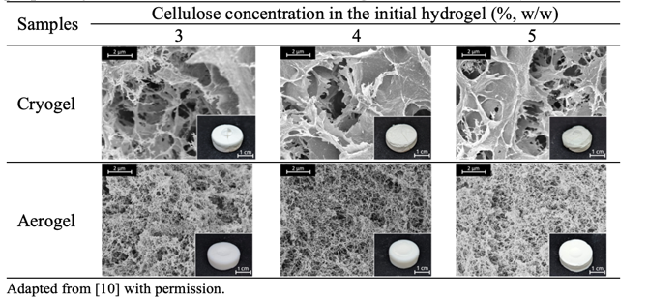
The visual appearance and the microstructure of cryogel and aerogel monoliths are presented in Table 1. Cryogels were visually opaque with evident cracking, while aerogels appeared more homogeneous. These results were associated with the microstructural feature: cryogels had larger pores with flat walls in comparison to aerogels showing a fibrillated network with smaller pores. The conversion of hydrogels into cryogels resulted in a slight increase in volume (5 – 10%), attributed to ice crystal growth during freeze-drying. In contrast, aerogel preparation caused a volume contraction (≈ 23%), likely due to differences in solubility parameters between cellulose, ethanol, and CO₂. Consequently, cryogels had lower density (0.056 – 0.077 g cm⁻³) than aerogels (0.077 – 0.112 g cm⁻³) prepared from cellulose solutions of the same concentration, while higher cellulose concentrations led to denser cryogels and aerogels. Both cryogels and aerogels exhibited high porosity (> 90%), with slightly lower porosity observed in aerogels. The specific surface area (S_{BET}), which indicates the presence of mesopores and small macropores (< 200 nm), was more than 10 times higher for aerogels (~ 380 m² g⁻¹) compared to cryogels (~ 30 m² g⁻¹). This observation agrees with SEM analysis. Due to these characteristics, cryogels exhibited lower firmness compared to aerogels (Figure 1) due to the weaker structure caused by the FD ice crystal growth.

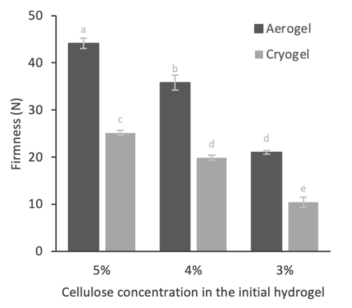
3.2 Interaction with oil
The potential use of cellulose cryogels and aerogels as innovative fat replacers requires understanding their interaction with oil. The kinetics of oil absorption by cryogels and aerogels is reported in Figure 2A. Cryogels exhibited faster oil absorption compared to aerogels, reaching the equilibrium within 15-60 minutes, while aerogels showed more gradual absorption kinetics (200-250 minutes). These variations in absorption kinetics can be attributed to the different morphology of cryogels and aerogels, with aerogels having smaller pores compared to cryogels.
In Figure 2B, the maximum oil absorption values of the materials are plotted against the material pore volume. The absorption values ranged from 4 to 8 g_{oil}/g_{dry matter} for aerogels and 8 to 13 g_{oil}/g_{dry matter} for cryogels, reflecting the different pore volumes of the materials. This highlights the significant role of material pore volume in determining fluid uptake at equilibrium, in fact, an R² = 0.96 linear correlation was found. Regarding their ability to absorb oil and retain it, OHC was tested and excellent results were obtained (> 96%), regardless of their morphological feature.
Figure 1. Firmness of cryogel and aerogels prepared from cellulose solution containing 3, 4, 5% (w/w) cellulose. ^{a-e}: values in different letters are statistically different (p<0.05).
These results demonstrate that cellulose aerogels and cryogels can absorb substantial amounts of oil with interesting potentialities for food applications. For this reason, further experiments were performed to improve the plasticity of the resulting material.
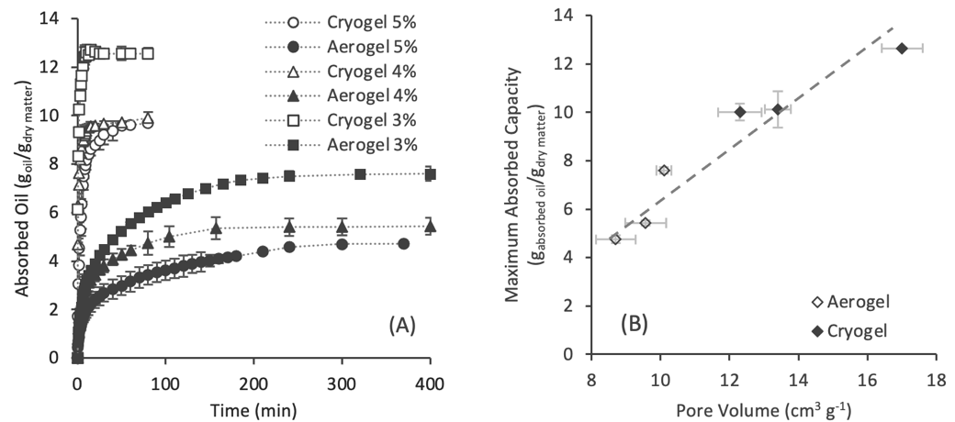
Figure 2. (A) oil absorbing kinetics and (B) maximum oil absorption capacity of cryogel and aerogel prepared from hydrogels containing 3, 4, 5% (w/w) cellulose. Dashed line in (B) is the least square approximation with R2 = 0.96. Adapted from Ciuffarin et al (2023) with permission.

3.3 Cellulose-based oleogel preparation and characterization
Despite the good oil absorption capability, monoliths resulted in hard materials not applicable to mimic the functionalities of plastic fat. Thus, cryogel monoliths were ground before drying to obtain fine particles that potentially could absorb oil and generate a plastic material. Cryogel particle microstructure and oleogel characterization results are reported in Table 2.

Table 2. SEM of cellulose cryogels particles (from 5% cellulose hydrogel) and macroscopic appearance, confocal microscopy (blu = cellulose, pink = oil), firmness, and rheological parameters of cellulose-based oleogel.
Particles |  | Oleogel
SEM |  | Macroscopic  Appearance | Confocal Microscopy | Firmness (N) | Critical Stress (Pa) | G' × 10⁴ (Pa)
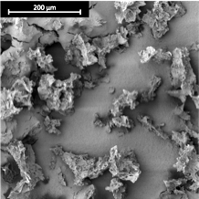 |  |  |  | 4.99 ± 0.71 | 192 ± 37 | 203.1 ± 35.6

As visible from SEM images (Table 2), cellulose particles presented an uneven fibril-like surface, similar to that observed in the cryogel monolith (Table 1), characterized by the presence of pores. The observed porosity was confirmed by the density of 0.31 g cm⁻³, much lower than that of the microcrystalline cellulose used for their preparation (0.42 g cm⁻³). As noticeable in Table 2, a self-standing material was obtained upon oil addition, showing a firmness value of 4.99 N and gel-like behavior being G' > G''. Moreover, viscoelastic properties were comparable to those of traditional plastic fats in terms of critical stress and G' values (Patel et al., 2020).
As outlined in the study by Plazzotta et al. (2020), the ability of dried templates to structure oil can be attributed to two key mechanisms: the pore capacity to absorb oil through capillary forces, both within its inner structure and at the surface where particles and oil interact; the formation of a biopolymer network that entraps oil in the interstitial spaces between particles, facilitating particle-particle interactions through hydrogen bonding. Confocal microscopy of cellulose-based oleogel (Table 2) confirmed the occurrence of both mechanisms, showing the embedding of the oil within pores as well as its holding in the interparticle spaces.

4. Conclusions and future perspectives

Results demonstrated that cellulose-based dried materials are promising oil-structuring templates. The drying technique applied to obtain the templates was found to significantly influence the morphology of the porous material, affecting the oil absorption and entrapping capacity, with cryogel being the best-performing material. Upon cryogel grinding before the drying step and further oil absorption, a self-standing oleogel with mechanical and rheological properties comparable to those of plastic fats can be obtained. These results open interesting opportunities to exploit cellulose as oil structuring material in food formulations with reduced saturated fat content. Future studies could better clarify the potentialities of cellulose-based oleogels for different food applications.

Acknowledgment: Part of this work was carried out in the framework of COST Action CA18125 “Advanced Engineering and Research of aeroGels for Environment and Life Sciences” (AERoGELS), funded by the European Commission, under the supervision of Prof. Tatiana Budtova (Mines ParisTech).

5. References
Brunauer, S., Emmett, P. H., & Teller, E. (1938). Adsorption of Gases in Multimolecular Layers. Journal of the American Chemical Society, 60(2), 309–319.
Buchtová, N., & Budtova, T. (2016). Cellulose aero-, cryo- and xerogels: towards understanding of morphology control. Cellulose, 23(4), 2585–2595.
Calligaris, S., Alongi, M., Lucci, P., & Anese, M. (2020). Effect of different oleogelators on lipolysis and curcuminoid bioaccessibility upon in vitro digestion of sunflower oil oleogels. Food Chemistry, 314, 126–146.
Ciuffarin, F., Alongi, M., Peressini, D., Barba, L., Lucci, P., & Calligaris, S. (2023). Role of the polyphenol content on the structuring behavior of liposoluble gelators in extra virgin olive oil. Food Chemistry, 412, 135572.
Ciuffarin, F., Négrier, M., Plazzotta, S., Libralato, M., Calligaris, S., Budtova, T., & Manzocco, L. (2023). Interactions of cellulose cryogels and aerogels with water and oil: Structure-function relationships. Food Hydrocolloids, 140, 108631.
De Vries, A., Hendriks, J., Van Der Linden, E., & Scholten, E. (2015). Protein Oleogels from Protein Hydrogels via a Stepwise Solvent Exchange Route. Langmuir, 31(51), 13850–13859.
Manzocco, L., Plazzotta, S., Powell, J., de Vries, A., Rousseau, D., & Calligaris, S. (2021). Structural characterisation and sorption capability of whey protein aerogels obtained by freeze-drying or supercritical drying. Food Hydrocolloids, 122.
Patel, A. R. (2020). Biopolymer-based oleocolloids. In K. Pal, I. Banerjee, P. Sarkar, D. Kim, W.-P. Deng, N. K. Dubey, & K. B. T.-B.-B. F. Majumder (Eds.), Biopolymer-Based Formulations: Biomedical and Food Applications (pp. 587–604). Elsevier.
Patel, A. R., Cludts, N., Sintang, M. D. Bin, Lesaffer, A., & Dewettinck, K. (2014). Edible oleogels based on water soluble food polymers: Preparation, characterization and potential application. Food and Function, 5(11), 2833–2841.
Patel, A. R., Nicholson, R. A., & Marangoni, A. G. (2020). Applications of fat mimetics for the replacement of saturated and hydrogenated fat in food products. Current Opinion in Food Science, 33, 61–68.
Pires, J. R. A., Souza, V. G. L., Gomes, L. A., Coelhoso, I. M., Godinho, M. H., & Fernando, A. L. (2022). Micro and nanocellulose extracted from energy crops as reinforcement agents in chitosan films. Industrial Crops and Products, 186, 115247.
Plazzotta, S., Calligaris, S., & Manzocco, L. (2020). Structural characterization of oleogels from whey protein aerogel particles. Food Research International, 132, 109099.
Sun, C. (2005). True density of microcrystalline cellulose. Journal of Pharmaceutical Sciences, 94(10), 2132–2134.

