ECO-sustainable packaging materials for the food industry
(ECOPACKMAT)
Bellesia Tommaso (tommaso.bellesia@unimi.it)
DeFENS, Department of Food Environmental and Nutritional Sciences, University of Milan, Milan, Italy
Tutor: Prof. Stefano Farris

The activities described so far in the doctoral program have been completed. Specifically, I worked on the optimization of a multi-step cellulose extraction method by reducing its environmental impact, as well as on its standardization for different tested lignocellulosic biomasses. The cellulosic residue collected was systematically characterized via nuclear magnetic resonance (NMR) and with different magnification at the optical microscope. The production of nanostructure including cellulose nanocrystals (CNCs) was also successful, and the dimensional aspects thereof analyzed with dynamic light scattering technique (Particle Size Distribution), and atomic force microscopy (AFM).

Miglioramento del metodo di estrazione e caratterizzazione della cellulosa e dei nanocristalli
Le attività descritte fino ad ora nel programma di dottorato sono state concluse. Nello specifico, ho lavorato sull’ottimizzazione di un metodo multi-step per l’estrazione di cellulosa attraverso una riduzione dell’impatto ambientale associato, cercando altresì di standardizzarne le varie fasi per le diverse biomasse lignocellulosiche testate. Il residuo cellulosico raccolto post-estrazione è stato sistematicamente caratterizzato per quanto concerne composizione (mediante risonanza magnetica nucleare ‒ NMR) e morfologia (mediante microscopia ottica). E’ stata inoltre effettuata con successo l’estrazione di nanocristalli di cellulosa (CNCs), caratterizzati per quanto concerne morfologie e dimensione mediante microscopia a forza atomica (AFM) e dynamic light scattering (DLS).
Keywords: Cellulose, cellulose nanocrystals (CNCs), food packaging, nuclear magnetic resonance (NMR), circular economy.

1. Introduction
In accordance with the research plan of the PhD work, here are presented the outcomes of the initial two work packages (WP) and related tasks regarding:
(WP1) Cellulose extraction from different lignocellulosic biomasses and NMR characterization, production of cellulose nanocrystals from cellulosic residue and characterization thereof through DLS and AFM techniques.
(WP2) Bulk addition of CNCs into paper-based materials.

2. Materials and Methods
This work starts with the extraction of cellulose from several lignocellulosic biomasses (e.g., giant-cane cut up, Posidonia oceanica, and coffee silverskin) and finishes with the production of CNCs. Cellulose recovery was performed via a multi-step procedure previously described in our recent work. Briefly, the partial removal of hemicellulose and lignin was obtained using a sodium hydroxide solution upon stirring at room temperature. Secondly, xylene was applied to remove small MW organic compounds. Finally, a bleaching treatment with sodium chlorite washed out both pigments and lignin residues. Each extraction step was followed by washing with water, ethanol or acetic acid, filtration, and further drying in an oven at 105°C. The so-obtained cellulosic residue represented the input for the CNCs production. The latter involved the treatment of the solid with a strong sulfuric acid solution, anticipated by a homogenization step needed to boost the acid penetration inside the cellulosic core. Afterward, the solid-liquid separation was achieved by centrifugation, whereas the pH of the obtained CNCs was raised up to 4.5 through several washing steps. At last, pH was adjusted to neutrality using a dialysis tube against deionized water.

3. Results and Discussion

3.1 Determination of the yield and characterization of cellulose
Table 1 displays the results of cellulose extraction yield obtained in this work, together with those already observed by other authors in the literature when testing the same biomasses.
SUBSTRATE | Experimental cellulose yield  (% dry basis) | Cellulose yield from literature  (% on dry basis)
Giant-cane cut up | ~38.60 | ~38.20
Posidonia Oceanica | ~43.10 | ~40.20
Coffee silverskin | ~23.40 | ~23.80
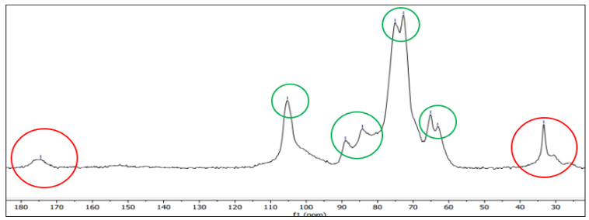
The slight difference detected between the current results and those from the literature (Table 1) can be ascribed to the presence of some impurities (e.g., lignin and hemicellulose residues), as clearly visible from the NMR spectrum pertaining to the cellulose recovered from Posidonia Oceanica (Figure 1). Therefore, further efforts must be made in the nearby future to eventually increase the cellulose purity inside the final residue.
Figure 1: NMR spectrum of Posidonia Oceanica (the red circles represent the impurities, lignin and hemicellulose, while the green circles belong to the cellulose carbon atoms).
Table 1: Comparison between yields of cellulose extraction found in this work and those retrieved from literature.

3.2 Percentage of CNCs and characterization
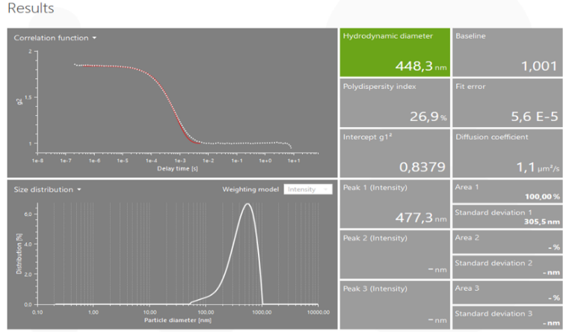
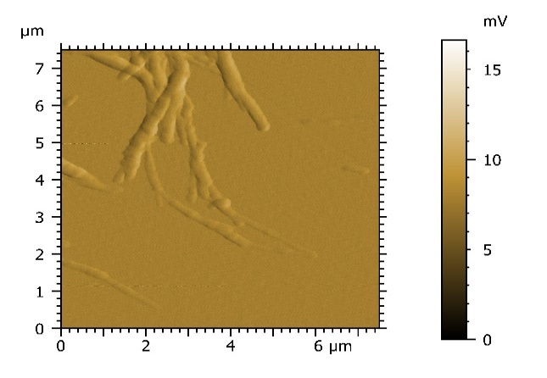
According to the morphological study, the final particles obtained after acid hydrolysis cannot properly be defined as CNCs because of a size slightly bigger than the ‘nano’ scale as supported by the acquisition of the AFM images (Figure 2) and consistent with the data from the particle analyzer (Figure 3).
Figure 3: software image of particle analyzer after analysis of nano structure solution
Figure 2: AFM image of nanostructure

3.2 Preparation of cellulose sheet and bulk insertion of CNCs
In this frame, I would like to impregnate the cellulose sheet with some water-proof compounds (e.g., natural waxes), as well as to improve the oxygen barrier properties thereof via addition of CNCs. However, this task is still at the early developing stages, despite I found interesting research articles that can be helpful to reach the goal within the next year.

4. References
- Luis Suárez et al. Giant Reed (Arundodonax L.) Fiber Extraction and Characterization for Its Use in Polymer Composites, Journal of Natural Fibers, 20:1, 2131687 (2023)
- Rovera, C., Carullo, D., Bellesia, T., Büyüktaş, D., Ghaani, M., Caneva, E., & Farris, S. (2023). Extraction of high-quality grade cellulose and cellulose nanocrystals from different lignocellulosic agri-food wastes. Frontiers in Sustainable Food Systems, 6 doi:10.3389/fsufs.2022.1087867
- Nishimura, H., Kamiya, A., Nagata, T. et al. Direct evidence for α ether linkage between lignin and carbohydrates in wood cell walls. Sci Rep 8, 6538 (2018). https://doi.org/10.1038/s41598-018-24328-9

