Vegetable agri-food by-products: a source of functional ingredients for the production of high added value foods
Giuditta de Gennaro (giuditta.degennaro@uniba.it)
Dept. of Soil, Plant and Food Science, University of Bari Aldo Moro, Italy
Tutor: Prof. Francesco Caponio; Co-tutor: Dott.ssa Graziana Difonzo

This PhD thesis aimed to formulate high added value foods through the exploitation of plant-based waste and by-products to be used as innovative ingredients or a source from which to extract bioactive molecules in a sustainable way. Specifically, one of the main research activities was focused on the valorisation of globe artichoke roots as an alternative and sustainable source of inulin by green extraction and its application as ingredient for the production of functional fresh pasta.

Scarti e sottoprodotti vegetali come fonte di ingredienti funzionali per la produzione di prodotti alimentari ad alto valore aggiunto
Il presente progetto di dottorato ha avuto lo scopo di formulare alimenti ad alto valore aggiunto valorizzando scarti e sottoprodotti di origine vegetale mediante il loro utilizzo come ingredienti funzionali o fonte da cui estrarre molecole bioattive sfruttando metodiche green. Nello specifico, una delle principali attività di ricerca ha riguardato la valorizzazione di radici di carciofo come fonte alternativa e sostenibile per l’estrazione di inulina e sua applicazione come ingrediente innovativo per la produzione di pasta fresca funzionale.

Key words: plant-based; waste; by-products; green extraction; inulin; pasta.

1. Introduction
In recent years, the increasing awareness of consumer about the relationship between diet and health has led to the development of new foodstuffs. Vegetable and fruit processing industries generate a large amount of waste and by-products, including peels, roots, seeds, husks and pomace, representing a source of macromolecules and bioactive compounds like dietary fibre, proteins, essential fatty acids, polyphenols and other phytochemicals. All these molecules are well-known to have health beneficial effects, such as regulation of metabolic process, antioxidant and anti-inflammatory activity (Gómez et al., 2018). Italy is one the major producer of globe artichoke, which roots represents an important agricultural waste. Globe artichoke roots are rich in inulin, a fibre characterized by a mixture of oligo and polysaccharides consisting of a variable number of d-fructose units. The degree of polymerisation of this fibre affects both technological and nutritional properties; generally short-chain inulin is used as an alternative low-calorie sweetener, while long-chain inulin mixed with water form a gel network which can be used as a fat replacer or texture modifier. Moreover, the peculiar bond configuration confers to inulin a prebiotic characteristics (Raccuia et al., 2010; López-Molina et al., 2005). A regular intake of prebiotics has several benefits like modulation of hyperglycaemia, reduction of LDL cholesterol and serum lipids, enhancement of immune system. Fresh pasta is a product spread worldwide and daily consumed, rich in carbohydrate but relatively poor in other nutrients (dietary fibre), representing a suitable food to deliver functional ingredients like inulin (Bianchi et al., 2022). Several studies have tried to improve the nutritional profile of pasta by adding soluble and insoluble fibre, finding conflicting results in terms of technological quality.
In this perspective, this oral communication reports the main results of the following activities:
A1) green extraction of inulin from globe artichoke roots;
A2) characterisation of extracted inulin;
A3) fresh pasta production and evaluation of the inulin addition on textural, sensory and nutritional properties.

2. Materials and Methods
2.1 Extraction and characterisation of inulin from globe artichoke roots
Inulin green extraction was carried out according to Difonzo et al. (2022). For the extraction process it was used water (pH = 6.8) as solvent with a ratio solid to water of 1:16 (w/v). The extraction consisted of 2 h of brewing at 80 ºC, followed by filtration and precipitation steps. Afterwards, the sample was centrifugated, washed with ethanol, centrifugated and the pellet dried overnight. Inulin yield (%) = (weight of inulin (g))/(weight of artichoke roots (g)) × 100. Moisture content was determined with a moisture analyser and water activity (a_{w}) using a hygrometer. Identification and quantification of inulin was carried out through high-performance liquid chromatography (HPLC) equipped with a refractive index detector (RID) and a cationic exchange column. The analysis was conducted isocratically using Milli-Q water as mobile phase with a flow of 0.6 mL min⁻¹, column temperature 80 ºC and RID 35 ºC, commercial inulin with high degree of polymerisation and high purity was used as a standard. Number average degree of polymerisation (DPn) and weight average degree of polymerisation (DPw) of extracted inulin were evaluated using a gel permeation chromatography. The injection volume was 100 μL and flow rate of 0.8 mL DPn and DPw were calculated using the following equation: Mn = 180 + 162 × (DPn – 1), Mw = 180 + 162 × (DPw – 1); Mn is the number average molecular weight, while Mw is the weight average molecular weight.

2.2 Fresh pasta preparation
Inulin-enriched fresh pasta was produced by replacing 5% (P5), 10% (P10) and 15% (P15) of durum wheat semolina with inulin. Control pasta (PC) was produced with 100% of durum wheat semolina. The flour was mixed with an adequate amount of water and manually kneading, the dough was then laminated and cut to produce tagliatelle pasta. Tagliatelle were left dried until reaching 26-28% of moisture content and a_{w} values ranging from 0.92-0.97, according to the Italian legal requirements for fresh pasta production and marketing.

2.3 Fresh pasta characterisation
2.3.1 Cooking properties of fresh pasta
Pasta samples were cooked in boiling distilled water at 1:10 (w/v), without the addition of salt, according to Pasqualone et al. (2016). The optimum cooking time (OCT) was determined according to the AACC 16-50 official method (AACC, 2000), cooking loss (CL), water absorption (WAI) and swelling index (SI) was determined according to Bustos et al. (2011). Inulin loss (IL) in cooking water (g 100 g⁻¹ of pasta) was determined analysing its inulin content by a cationic exchange HPLC following the same methods described in section 2.1.

2.3.2 Instrumental and sensory analysis of fresh pasta
Colour (L*, luminosity; a*, redness; b*, yellowness) of raw and cooked fresh pasta was evaluated using a colorimeter. Pasta firmness, cooked at their OCT, was assessed measuring the maximum force (N) required to cut 5 strands of pasta at a speed of 0.17 mm s⁻¹. The microstructure and the surface characteristics of raw pasta were studied with a Zeiss Sigma 300 VP field-emission gun scanning electron microscope (FEG-SEM) equipped with a secondary electrons detector (SE).
Sensory analysis was conducted on fresh pasta, cooked at OCT, by a panel of eight trained testers which evaluated the colour, odour, taste, bulkiness, adhesiveness and firmness, using a structured scale ranging from 1 to 10.

2.4. Proximate composition and functional properties
Proteins (total nitrogen × 5.7), ashes, lipids and total dietary fibre content were determined using the AOAC method 979.09, 923.03, 945.38F, and 991.43, respectively (AOAC, 2006). Moisture content was determined by a moisture analyser, while carbohydrate content was determined as difference. In vitro starch hydrolysis was determined according to Liljeberg et al. (1996). Free glucose was determined using an enzyme-based kit and converted into hydrolysed starch in pasta. Control white bread was used as a control to estimate the hydrolysis index (HI) = 100. The predicted glycaemic index (pGI) was calculated using the equation pGI = 0.549 × HI + 39.71 (Capriles et al., 2013).
To evaluate the prebiotic activity of inulin-enriched fresh pasta, samples were subjected to in vitro gastrointestinal digestion according to the method used by Kamiloglu and Capanoglu (2014). Twenty-two probiotic strains and one strain of Escherichia coli (E. coli) were used to carry out the experimental in faecal medium (FM). The FM was constituted as described by Vacca et al. (2021) in absence of carbohydrates, FMPC (FM + control pasta), FMP5 (FM + pasta with 5% of inulin), (FM + pasta with 10% of inulin) and FMP15 (FM + pasta with 15% of inulin). Prebiotics and E. coli were incubated in FM at density of 7 UCF mL⁻¹. After the incubation, plate counts for lactic acid bacteria and E. coli were respectively made in De Man, Rogosa, and Sharpe agar (MRS) and Violet Red Bile Glucose agar (VRBGA). Probiotic growth was also profiled in terms of ΔpH, as the difference between final (36 h) and initial (pH 7.0 ± 0.02) values of pH.

2.5 Statistical analysis
The experimental data were subjected to one-way and two-way ANOVA, followed by a Tukey’s HSD test. The two-way ANOVA analysis was carried out considering the rate of substitution and the physical state of pasta (raw and cooked) as factors. Significant differences among the values of all the parameters were determined at p-value < 0.05 by the Minitab 17 Statistical Software (Minitab, Inc., State College, PA, USA, 2010).

3. Results and Discussion
3.1 Inulin powder characterisation
The extraction yield of inulin can be influenced by several factors such as: temperature, time of extraction or the ratio solid/liquid (Rubel et al., 2018). From the data collected, the extraction yield of inulin from globe artichoke roots was 23.37 g 100 g⁻¹, with a purity level of 89%, estimated in comparison to commercial inulin used as a standard. Moreover, the extracted inulin showed a DPn and DPw equal to 45 and 60, respectively, a moisture content of 6% and a_{w} of 0.40, values which assure high glass transition temperature, lower cohesiveness and good physical and microbiological stability (Jirayucharoensak et al., 2019).

3.2 Quality characteristics of fresh pasta
Pasta cooking properties are of great importance for ensuring consumers acceptability. Table 1 shows the OCT, SI, WAI and CL of fresh pasta samples. OCT was set for each pasta sample, observing a slight increase in P10 and P15; WAI, showed no significant differences among the sample, while a lower values of SI were found for P10 and P15 than PC. As regard CL, good quality pasta should not have a CL higher than 7-8%, our results showed a CL between 2.37% for PC and 3.62% for P15. Specifically, IL accounted for 1.01 g 100 g⁻¹ for P5, 1.45 g 100 g⁻¹ for P10 and 2.19 g 100 g⁻¹ for P15. The low SI and CL values obtained can be related to the encapsulation of starch granules into fibre reticule, which limited the penetration of water into starch granules and provided an extra support to the protein network, reducing the solid loss (Liu et al., 2016). However, discordant results were found in literature probably due to the different production process, the fibre added and their interaction with other ingredients (Simonato et al., 2019; Zarrough et al., 2022).
Table 1 Cooking properties of fresh pasta.
Sample | OCT (min) | WAI (g 100 g⁻¹) | SI | CL (g 100 g⁻¹) | IL (g 100 g⁻¹)
PC | 6.30 | 73.20 ± 0.01 a | 1.56 ± 0.03 a | 2.37 ± 0.05 d | -
P5 | 6.30 | 73.24 ± 0.10 a | 1.53 ± 0.04 ab | 2.70 ± 0.14 c | 1.01 ± 0.03 c
P10 | 6.45 | 72.51 ± 0.62 a | 1.48 ± 0.03 b | 3.11 ± 0.07 b | 1.45 ± 0.07 b
P15 | 6.45 | 73.24 ± 0.20 a | 1.47 ± 0.04 b | 3.62 ± 0.06 a | 2.19 ± 0.12 a
PC, control pasta without inulin addition; P5, pasta with 5% of inulin added; P10, pasta with 10% of inulin added; P15, pasta with 15% of inulin added. OCT, optimal cooking time; WAI, water absorption index, SI, swelling index; CL, cooking losses; IL, inulin losses. Values are expressed as mean ± standard deviation; different letters in the same column mean significant statistical differences (p < 0.05) to one-way ANOVA followed by Tukey’s HSD test.

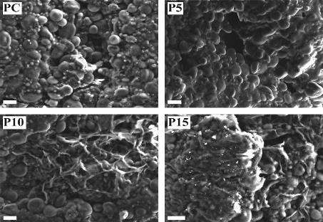
Table 2 shows the colour and firmness of raw and cooked pasta. According to two-way ANOVA, both the cooking process and inulin addition significantly affect the colorimetric parameters. Both in raw and cooked pasta occurred a reduction of L* and b* with higher substitution rate of durum wheat semolina with inulin. The red index (a*) followed the same trend for cooked pasta, while an opposite trend was observed considering the increasing rate of substitution. Firmness of pasta is strictly related to protein matrix development during pasta production and hydration level of starch granules (Simonato et al., 2019). Cooked P10 and P15 showed higher firmness than PC and P5, this increase can be attributed to the lower values of SI found and to a rearrangement of pasta structure as observed through SEM micrographs of raw pasta (Figure 1), where P10 and P15 exhibited the presence of a reticulated structure, supporting the hypothesis discussed above.
Figure 1 SEM micrographs of raw pasta of Control pasta (PC), pasta with 5% of inulin (P5), 10% (P10) and 15 % (P15).
Table 2 Colour and textural properties.
 |  | L* | a* | b* | Firmness
Raw pasta | PC | 79.65 ± 0.09 a | 2.21 ± 0.07 e | 33.57 ± 0.46 a | 18.25 ± 0.45 b
 | P5 | 74.57 ± 0.19 c | 3.21 ± 0.02 c | 30.49 ± 0.26 b | 19.63 ± 0.50 a
 | P10 | 72.02 ± 0.38 e | 3.89 ± 0.10 b | 28.52 ± 0.19 c | 19.89 ± 0.05 a
 | P15 | 70.72 ± 0.25 f | 4.48 ± 0.08 a | 27.62 ± 0.09 cd | 19.77 ± 0.23 a
Cooked pasta | PC | 78.89 ± 0.43 b | 0.30 ± 0.02 f | 27.11 ± 0.56 d | 5.85 ± 0.36 d
 | P5 | 73.69 ± 0.18 d | 2.00 ± 0.11 e | 24.13 ± 0.41 e | 6.22 ± 0.26 d
 | P10 | 72.24 ± 0.06 e | 2.82 ± 0.11 d | 24.18 ± 0.33 e | 7.37 ± 0.48 c
 | P15 | 68.12 ± 012 g | 3.79 ± 0.10 b | 22.29 ± 0.43 f | 7.25 ± 0.37 c
p-value | P *C | <0.0001 | <0.0001 | <0.0001 | <0.05
PC, control pasta without inulin addition; P5, pasta with 5% inulin added; P10, pasta with 10% inulin added; P15, pasta with 15% inulin added. P, percentage of inulin addition; C, cooking process. Values are expressed as mean ± standard deviation; different letters in the same column mean significant statistical differences (p < 0.05) according to two-way ANOVA.
The sensory analysis results are reported in Figure 2. The increasing rate of substitution of durum wheat semolina with inulin did not cause significant changes in sensory perceptions. Colours and texture scores were consistent with instrumental evaluation. Significant differences were found for taste of all inulin-enriched samples than control, while panellists perceived an odour significant different only for P15.

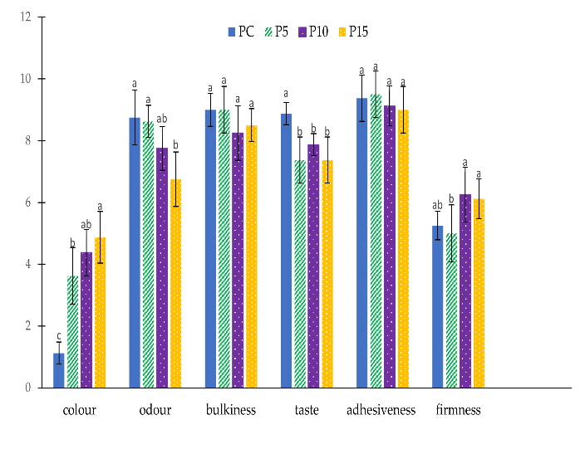
3.3 Functional properties of fresh pasta
Figure 2. Sensory analysis of fresh pasta.
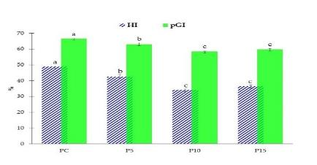
The proximate composition of pasta showed a decline in protein content of inulin-enriched pasta (~ 9 g 100 g⁻¹) than PC (~ 11 g 100 g⁻¹), due to a rise in total dietary fibre content, which reached values of 3.44 g 100 g⁻¹ in P5, 8.16 g 100 g⁻¹ in P10, and 12.41 g 100 g⁻¹ in P15. Therefore, the results in terms of total dietary fibre allow to label P5 as a “source of fibre”, while P10 and P15 as pasta having “high fibre content” according to Reg. (EU) 1924/2006, enhancing the nutritional value of fresh pasta. Moreover, higher ash and lower lipid content were found in P10 and P15 than P5 and PC (data not showed).
Figure 3. Hydrolysis index (HI) and predicted glycaemic index (pGI).

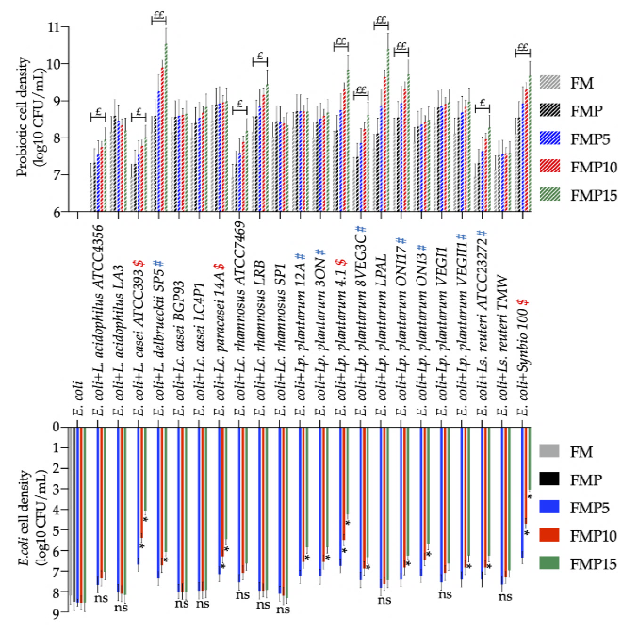
Cooked pasta was analysed for in vitro starch hydrolysis, as shown in Figure 3, the addition of inulin in fresh pasta promoted the decrease in HI and pGI. The HI and pGI values of fresh pasta samples enriched with inulin (P5, P10 and P15) were significantly lower than PC. P5 reached a significantly lower value of pGI compared to the control (PC): 63.01 and 66.54%, respectively. A higher concentration of inulin resulted in a further decrease of HI and pGI, as shown in P10 and P15. In fact, the gelling effect of these fibres causes the formation of a film on the walls of the stomach and gut with consequent lower absorption of fats and sugars (Kumar et al., 2012).
Figure 4. Cell density of 22 probiotics co-cultured with E.coli in faecal batches not containing carbohydrate (FM), with the addition of pasta without inulin (FMP), pasta with 5% of inulin (FMP5), 10 % (FMP10) and 15 % (FMP15).
The prebiotic activity of inulin-enriched pasta was assessed in vitro in terms of probiotics growth and the inhibition of E.coli when co-cultured with probiotics (Figure 4). The addition of pasta in the batches (FMP) was sufficient to increase (~0.5 log₁₀ CFU mL⁻¹) the cell density of all the tested prebiotics, due to the presence of fructans and arabinoxylans naturally occurring in wheat. However, the presence of 3 g L⁻¹ of inulin in FMP15 was able to increase of > 0.5 cycle the cell density of 50% of used probiotics and more than 1 cycle of 27 % of used strains. No significant difference were found comparing the cell density of E.coli in FMP to FMP5. However, more than 50% of used prebiotics were able to significantly decrease the cell density of E.coli in FMP15, and 36 % in FMP10. These results are in line with those stated by Kareem et al. (2014), who reported that the combination of probiotics with prebiotics in vitro exhibited a great inhibition of pathogens due to a synergic effect.

4. References
AACC. Approved Methods of Analysis, 11th ed.; AACC International: St. Paul, MN, USA, 2000.
AOAC International. Official Method of Analyisis, 17th ed.; AOAC International: Gaithersburg, MD, USA, 2006.
Bianchi F, Giuberti G, Cervini M, Simonato B (2022). Fortification of durum wheat fresh pasta with Maqui (Aristotelia chilensis) and its effects on technological, nutritional, sensory properties, and predicted glycemic index. Food and Bioproc Tech 15: 1563-1572.
Bustos M. C, Pérez G. T, León A. E. (2011). Effect of four types of dietary fiber on the technological quality of pasta. Food Sci and Technol Int 17: 213-221.
Capriles V. D, Arêas, J. A. (2013). Effects of prebiotic inulin-type fructans on structure, quality, sensory acceptance and glycaemic response of gluten-free breads. Food & Funct 4: 104-110.
Difonzo G, de Gennaro G, Caponio G. R, Vacca M, Dal Poggetto G, Allegretta I, Immirzi B, Pasqualone A. (2022). Inulin from Globe Artichoke Roots: A Promising Ingredient for the Production of Functional Fresh Pasta. Foods 11: 3032.
Gómez M, Martinez M. M. (2018). Fruit and vegetable by-products as novel ingredients to improve the nutritional quality of baked goods. Crit Rev Food Sci Nutr 58: 2119-2135.
Jirayucharoensak R, Khuenpet K, Jittanit W, Sirisansaneeyakul S. (2019). Physical and chemical properties of powder produced from spray drying of inulin component extracted from Jerusalem artichoke tuber powder. Dry 37: 1215-1227.
Kamiloglu S, Capanoglu E. (2014). In vitro gastrointestinal digestion of polyphenols from different molasses (pekmez) and leather (pestil) varieties. Int. J. Food Sci. Technol. 49: 1027-1039.
Kumar V. V, Kumar M. P, Thiruvenkadaravi K. V, Baskaralingam P, Kumar P. S, Sivanesan S. (2012). Preparation and characterization of porous cross linked laccase aggregates for the decolorization of triphenyl methane and reactive dyes. Bioresour. Technol. 119: 28-34.
Liljeberg H, Åkerberg A, Björck, I. (1996). Resistant starch formation in bread as influenced by choice of ingredients or baking conditions. Food chem 56: 389-394.
López-Molina D, Navarro-Martínez M. D, Rojas-Melgarejo F, Hiner A. N, Chazarra S, Rodríguez-López J. N. (2005). Molecular properties and prebiotic effect of inulin obtained from artichoke (Cynara scolymus L.). Phytochemistry 66: 1476-1484.
Liu J, Luo D, Li X, Xu B, Zhang X, Liu J. (2016). Effects of inulin on the structure and emulsifying properties of protein components in dough. Food Chem 210: 235-241.
Pasqualone A, Gambacorta G, Summo C, Caponio F, Di Miceli G, Flagella Z, Marrese P. P, Piro G, Perrotta C, De Bellis L, Lenucci M. S. (2016). Functional, textural and sensory properties of dry pasta supplemented with lyophilized tomato matrix or with durum wheat bran extracts produced by supercritical carbon dioxide or ultrasound. Food Chem 213: 545-553.
Raccuia S. A, Melilli M. G. (2010). Seasonal dynamics of biomass, inulin, and water-soluble sugars in roots of Cynara cardunculus L. Field crops Res, 116: 147-153.
Simonato B, Trevisan S, Tolve R, Favati F, Pasini G. (2019). Pasta fortification with olive pomace: Effects on the technological characteristics and nutritional properties. LWT 114: 108368.
Vacca M, Celano G, Lenucci M. S, Fontana S, Forgia F. M. L, Minervini F, Scarano A, Santino A, Dalfino G, Gesualdo L, De Angelis M. (2021). In vitro selection of probiotics, prebiotics, and antioxidants to develop an innovative synbiotic (NatuREN G) and testing its effect in reducing uremic toxins in fecal batches from CKD Patients. Microorganisms 9: 1316.
Zarroug Y, Boulares M, Sfayhi D, Slimi B, Stiti B, Zaieni K, Nefissi S, Kharrat M. (2022). Structural and Physicochemical Properties of Tunisian Quercus suber L. Starches for Custard Formulation: A Comparative Study. Polym 14: 556.

